Lab 6.4.3.5 - Building a Switch and Router Network (Simplified Version)

1. Topology

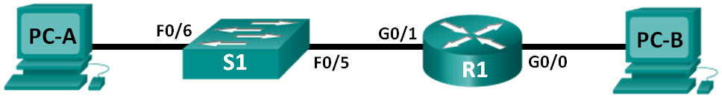

1. Addressing Table

|  |  |  |  |  |
| --- | --- | --- | --- | --- |
| Device | Interface | IP Address | Subnet Mask | Default Gateway |
| R1 | G0/0 | 192.168.0.1 | 255.255.255.0 | N/A |
|  | G0/1 | 192.168.1.1 | 255.255.255.0 | N/A |
| S1 | VLAN 1 | 192.168.1.5 | 255.255.255.0 | 192.168.1.1 |
| PC-A | NIC | 192.168.1.3 | 255.255.255.0 | 192.168.1.1 |
| PC-B | NIC | 192.168.0.3 | 255.255.255.0 | 192.168.0.1 |

* 1. Configure the router.
     1. Console into the router and enable privileged EXEC mode.
     2. Enter configuration mode.
     3. Assign a device name to the router.
     4. Disable DNS lookup to prevent the router from attempting to translate incorrectly entered commands as though they were host names.
     5. Assign **class** as the privileged EXEC encrypted password.
     6. Assign **cisco** as the console password and enable login.
     7. Assign **cisco** as the VTY password and enable login.
     8. Encrypt the clear text passwords.
     9. Create a banner that warns anyone accessing the device that unauthorized access is prohibited.
     10. Configure and activate both interfaces on the router.
     11. Configure an interface description for each interface indicating which device is connected to it.
     12. Save the running configuration to the startup configuration file.
     13. Set the clock on the router.

**Note**: Use the question mark (**?**) to help with the correct sequence of parameters needed to execute this command.

* + 1. Print screen your results as shown below:

|  |  |
| --- | --- |
| **From:** | **PING SUCCESSFUL ?** |
| PC-B (IPv4) To R1 |  |
| PC-B (IPv4) To S1 |  |
| PC-B (IPv4) To PC-A |  |